Field of diversity: | 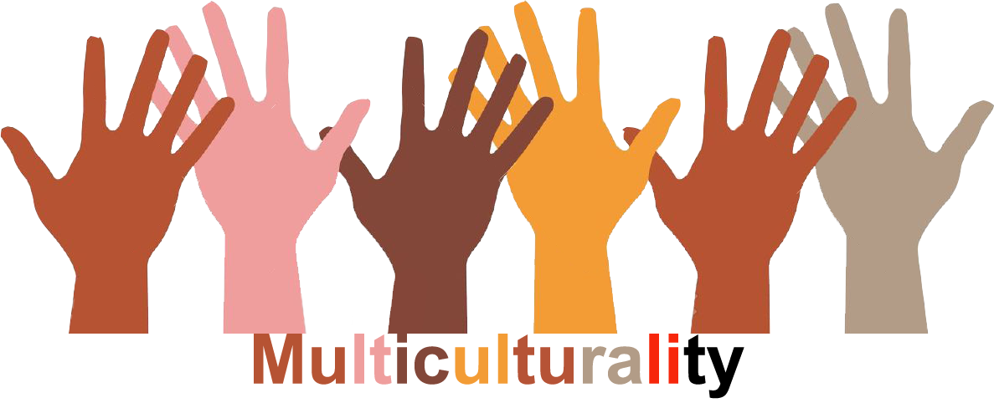 |  | L1 |  | Group size:
Title | Café philo
Content | Questioning each other's ideas and reflecting on them based on important issues |  |  |  | Time: 50’
Goals (Skills/Competences) | Ability to listen and understand other one's views and opinions
Material | Article – Text – Pictures according to the determined topic
Procedure: | A group of people want to discuss about a specific subject addressed to the school/classroom/society…  - Display questioning at some strategic locations in the school (f.i: the picture of the young migrant, Aylan, died on the beach; a group of migrants trying to enter Greece…)  - Students, teachers and other people interested in the subject and wish to participate register (just to have an idea of the number of participants – on posters, by telling to the responsible…)  - Announce the place and time of the meeting  - During the meeting, the exchange of ideas takes place in total freedom: each one can say anything with kindness and consideration. Everyone can come regardless of background, education or beliefs… There is no need to be knowledgeable in philosophy to contribute to the discussion  - The main ideas are put on posters and displayed in the hallways throughout the school
Modifications
Comments
Success  factors | Everyone (students, teachers, educators, headteachers, workers, administrative staff) is welcome! The more diversity, the richer exchange !  It can be interesting to have a mediator for the discussion to avoid any abuse regarding to some extremism (legality, religion…) | Pitfalls
The activity is flexible and depends on the local context. Feel free to adapt!
©
UDEL 21

