Field of diversity: | 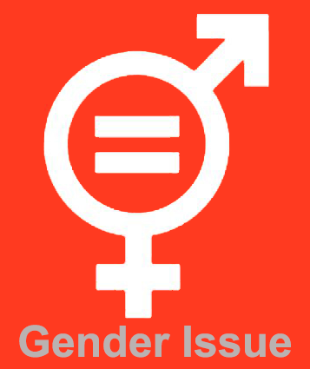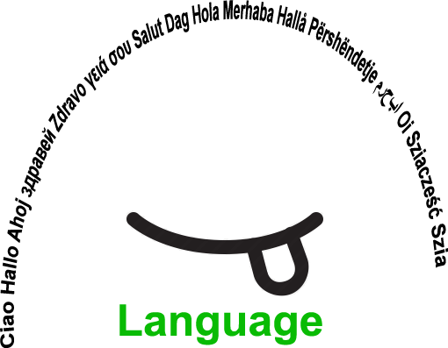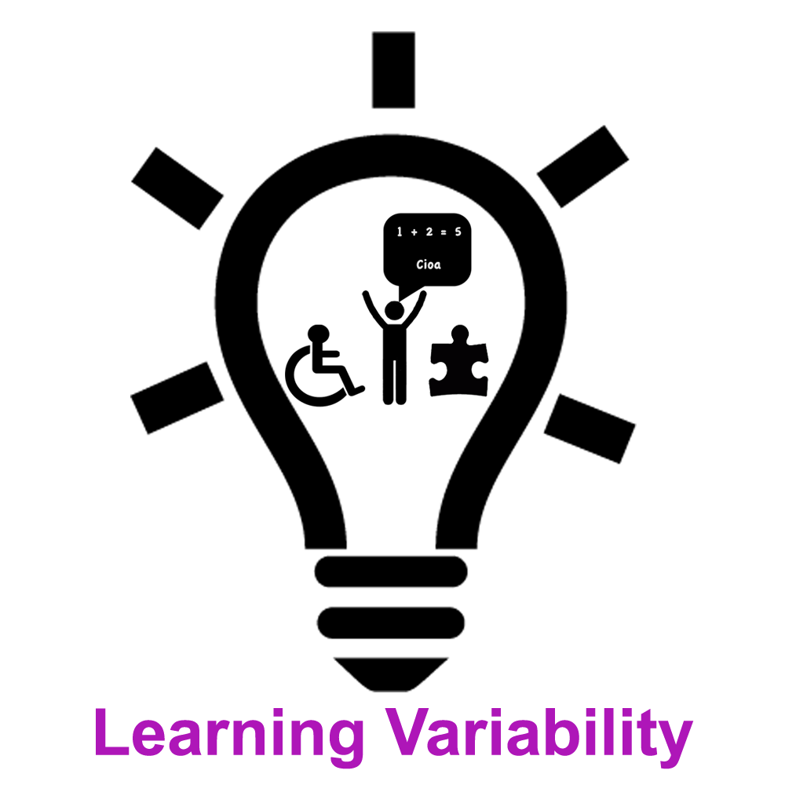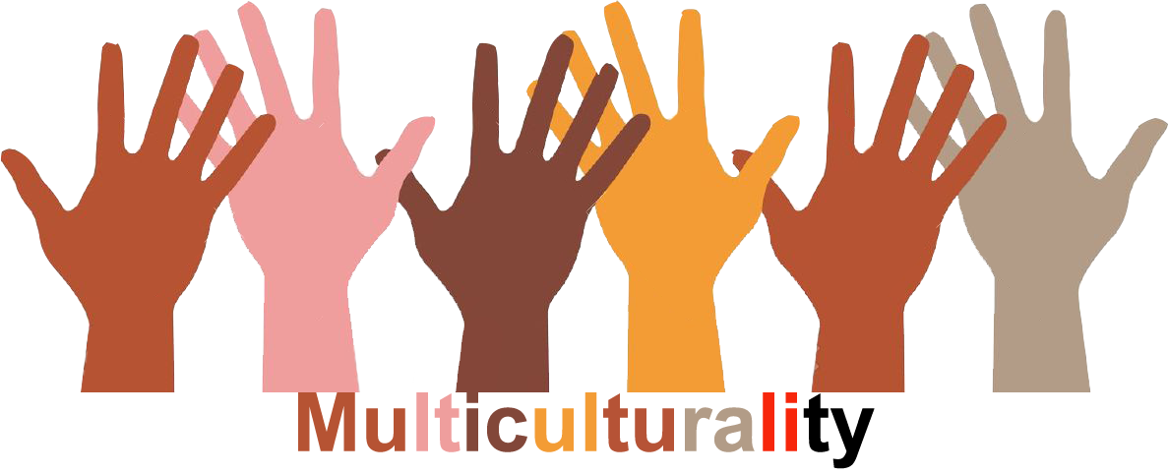 |  | GLLVM2_CZ  L1 |  | Group size:  For students from the age of 14 upwards
Title | Diversity and its beneficial and harmful aspects
Content | Students in pairs prepare a report on the issue "Is diversity beneficial/harmful?", present it to other pair which advocates opposite opinion. Later the position is swapped in the pairs. Finally, students synthesize and integrate the best information and reasoning from both sides into a joint position that all group members can agree to. |  |  |  | Time: 45–60 min
Goals Skills/Competences | To eplore and be aware of both controversial parts of diversity.  Skills: reasoning based on knowledge.
Material | 5 papers in attachment
Procedure: | Academic controversy: (conflict of ideas in cooperative context) on the theme of HUMAN DIVERSITY  1.Research and preparing positions (in pairs)  2. Positions presentations and advocating (in groups of four)  3.Open discussion  4. Reverse perspectives  5. Synthesis  (reading material is in the attachment)  Source: Johnson, D.W., Johnson, R.T. Human relations: valuing Diversity. Edina: IBC, 1999.
Modifications
Comments
Success  factors | knowledge of controversy rules, time structure  useful in the beginning of the course or long term workshop | Pitfalls |  | when participants are not aware of cooperative learning context
The activity is flexible and depends on the local context. Feel free to adapt!

