Field of diversity: | 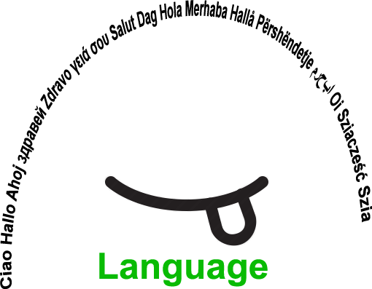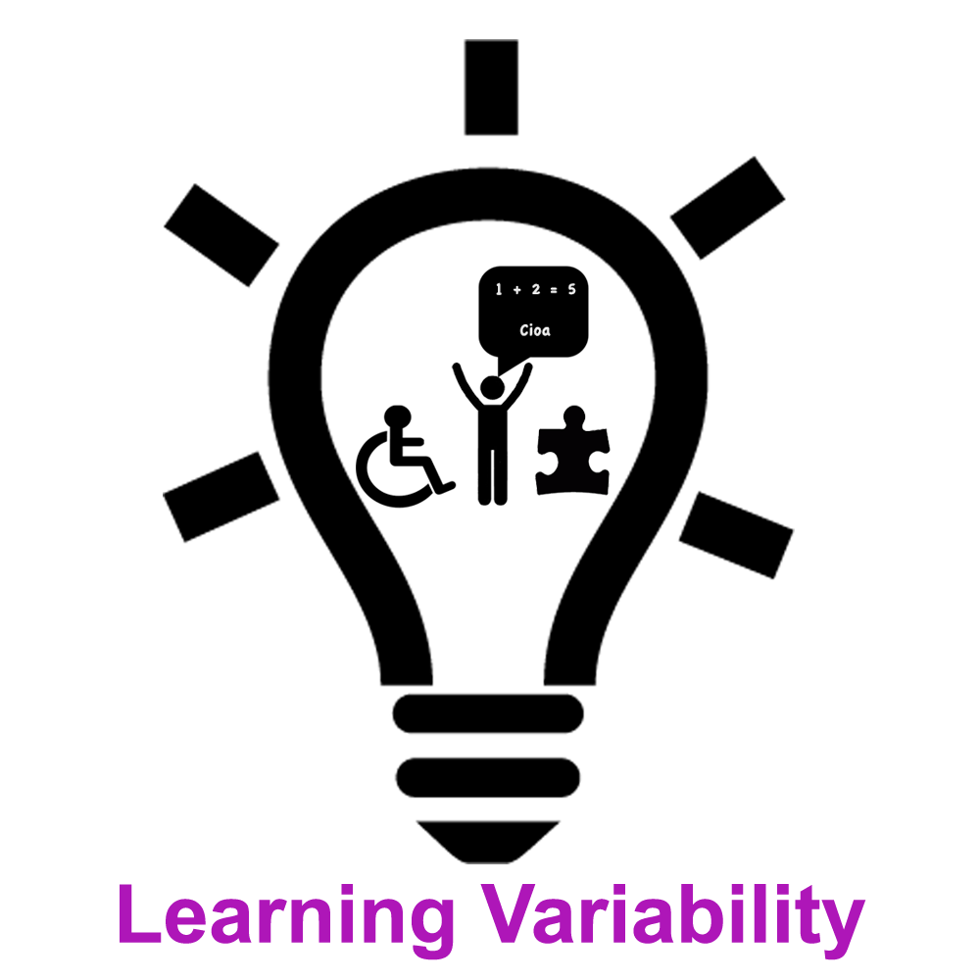 |  | L1 |  | Group size:  
Title | THE GREATEST TREASURE- a story about friendship
Content | A video story about friendship in 40 languages.  The boy with the name Peter is looking for treasure. On the way to find it, he meets some animals. Together they cross the ocean and find a wise owl who tells them, that by finding friendship, they have found the greatest treasure. |  |  |  |   Time: 3x45 min
Goals Skills/Competences | To develop social skills and to improve speaking competence.
Material | VIDEO The Greatest Treasure by Amit Garg : https://www.youtube.com/watch?v=OrgmTIMvcFI  INTERACTIVE EXERCISES AND GAMES: www.quizlet.com ,  INTERACTIVE ASSESSMENT TOOLS: http://www.onlineassessmenttool.com/  DVOLVER http://www.dvolver.com/moviemaker/make.html ,  FLIPPED LEARNING: http://flippedlearning.org/cms/lib07/VA01923112/Centricity/Domain/46/FLIP_handout_FNL_Web.pdf  GOGGLE PRESENTATIONS or STRIPGENERATOR http://stripgenerator.com/strip/create/  GOOGLE TRANSLATE or another online dictionary
Procedure: | - -At school: Learners do a survey on what they think the greatest treasure is, discussion in the classroom follows, it is the students’ choice if to participate in the discussion or not. LINK TO SURVEY  -At home: The learners watch the video, they choose the time, duration and the way of viewing the video and learning the vocabulary (watch, listen and read as many times as they want or need to), write down the words they find difficult to understand, look them up in an online dictionary, and practise pronunciation. -Back at school:  - In smaller groups (depending on the number of students in class) the learners present the work done at home, talk about the story, the task of the heroes, and solve problems with understanding the moral of the story. It is the learners’ choice to participate in the activity they find interesting or challenging. The teacher monitors the activity and offers support.  - Interactive activities in the computer classroom:  The learners do interactive exercises and games to improve vocabulary and grammar structures: guessing games, games on flashcards, answering questions, sorting out interactive exercises and quizzes (students choose the activities they want).  Further optional activities:  if they feel like it, they can create their own exercises, tests or games by using Online Exam Builder, Quizworks, Quiz Maker, Online Assessment Tool or create short videos by using DVOLVER, comics by using GOOGLE PRESENTATIONS on GOOGLE DRIVE or STRIPGENERATOR  + LINK: Article with instructions, ideas of how to proceed and links to interactive material
Modifications
Comments
Success    factors | Positive experience with the activities done so far and the material created by the students | Pitfalls   |  | Not being able to use ICT at home
The activity is flexible and depends on the local context. Feel free to adapt!

